AP Statistics.
The Idea of a Significance Test.
A Significance test is really just another way to do a confidence interval. So let’s collect some data.
- See how many cheerios you can catch in your mouth in two minutes when your partner is tossing them.
- Collect Class Data
Create a confidence interval for the true number of cheerios that is caught in two minutes.
- CYA:
  - SRS??????
  - Independence????
  - Normality?????
- Actual interval. Let the calculator do the heavy lifting for you.

The stated average of number of cheerios that can be caught is __________ cheerios. Is there convincing evidence that the actual mean is lower? BS!!!!!!!

Now let’s do the same thing with a significance test.
A significance test works like this: Suppose you think a parameter is a certain number. You would think if you collect data well your statistic should be really close to your parameter. What if it is not? One of two things is going on:
1) Ho is still true and you just are very unlucky.
2) Maybe Ho is not true.
A significance test actually shows the probability that you will get the results you got if Ho really is true. A very low probability gives us reason to question Ho
There are several things I will want to see all the time when you do a significance test. They are:
- Name of the test. This one is called a t-test for a mean. (more on this later)
- Ho:

- Ha:
- CYA: (same as for a Confidence Interval)

- Alpha level: This is the probability that would start questioning the null. It is usually 1-confidence level.

Now before we get to a test statistic, let’ s think about what is happening. If Ho is true then our data (which is spread out in an approximately normal distribution) should have Ho in the center. We also expect our statistic to be in around the same place. So we are asking how far away from Ho can we reasonably expect our statistic to be if Ho is really true? Would we expect the graph on the right to happen if Ho is really true?
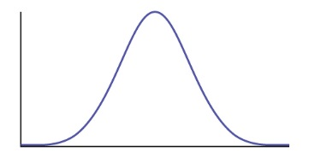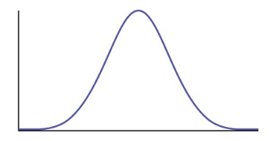
Ho xbar Ho

If we want to our alpha level to be .05 that mean we were 95% confident, which means we will start questioning data that is more than two standard deviations below the mean. So if our z-score for our data is less than -2 we may have reason to question Ho. So lets calculate the z-score. I know you remember the formula but here it is: (this will eventually change to t, not z, but for now I want you to just get the idea of a significance test)
So our z score is: _______________________________ This is called our
- TEST STATISTIC.
Is it below -2? If so we have to start questioning Ho.
What is the probability that we would get that test statistic if Ho is true? Use InvNorm (test stat,0,1) This is called the
- p-value. Compare it to the alpha level. Then finally I want to see a
- Written conclusion. Is there evidence to reject the Ho? Remember CONTEXT OF THE PROBLEM.

