**AP STATISTICS NAME: _________________________  
SPRING 2019 PERIOD: ___________________**

**CHAPTER 9 PRACTICE TEST**

**MUTLIPLE CHOICE – CHOOSE THE CORRECT ANSWER**

1. The average time it takes for a person to experience pain relief from aspirin is 25 minutes. A new ingredient is added to help speed up relief. Let *µ* denote the average time to obtain pain relief with the new product. An experiment is conducted to verify if the new product is better. What are the null and alternative hypotheses?

1. *H*0 : *µ* = 25 vs. *Ha* : *µ* 25
2. *H*0 : *µ* = 25 vs. *Ha*: *µ* < 25
3. *H*0 : *µ* < 25 vs. *Ha* : *µ* = 25
4. *H*0 : *µ* < 25 vs. *Ha*: *µ* > 25
5. *H*0 : *µ* = 25 vs. *Ha*: *µ* > 25

2. A significance test was performed to test the null hypothesis : *µ* = 2 versus the alternative

*Ha*: *µ* > 2. The test statistic is *z* = 1.40. The *P*-value for this test is approximately

(a) 0.16

(b) 0.08

(c) 0.003

(d) 0.92

(e) 0.70

3. A safety group claims that the mean speed of drivers on a highway exceeds the posted limit of 65 miles

per hour (mph). To investigate the safety group’s claim, which of the following statements is appropriate?

(a) The null hypothesis is that the mean speed of drivers on this highway is less than 65 mph.

(b) The null hypothesis is that the mean speed of drivers on this highway is greater than 65 mph.

(c) The alternative hypothesis is that the mean speed of drivers on this highway is greater than 65 mph.

(d) The alternative hypothesis is that the mean speed of drivers on this highway is less than 65 mph.

(e) The alternative hypothesis is that the mean speed of drivers on this highway is greater than or equal to 65 mph.

4. A significance test gives a *P*-value of 0.04. From this we can

(a) reject *H*0 at the 1% significance level.

(b) reject *H*0 at the 5% significance level.

(c) say that the probability that *H*0 is false is 0.04.

(d) say that the probability that *H*0 is true is 0.04.

5. In a test of *H*0: *µ* = 100 against *Ha*: *µ*  100, a sample of size 10 produces a sample mean of 103 and a *P-*value of 0.08. Thus, at the 0.05 level of significance

(a) there is sufficient evidence to conclude that *µ* 100.

(b) there is sufficient evidence to conclude that *µ* = 100.

(c) there is insufficient evidence to conclude that *µ* = 100.

(d) there is insufficient evidence to conclude that *µ* 100.

(e) there is sufficient evidence to conclude that *µ* = 103.

6. Which of the following is *not* a condition for performing inference about a population mean ?

(a) Inference is based on *n* independent measurements.

(b) The population distribution is Normal or the sample size is large (say *n* > 30).

(c) To use a *z* test, we must know the population standard deviation .

(d) The data are obtained from an SRS from the population of interest.

(e) Both *np* and *n*(1 – *p*) are 10 or greater.

7. Resting pulse rate is an important measure of the fitness of a person's cardiovascular system, with a lower rate indicative of greater fitness. The mean pulse rate for all adult males is approximately 72 beats per minute. A random sample of 25 male students currently enrolled in the Faculty of Agriculture was selected and the mean resting pulse rate was found to be 80 beats per minute with a standard deviation of 20 beats per minute. The experimenter wishes to test if the students are less fit, on average, than the general population.

The null and alternative hypotheses are

(a) 

(b) 

(c) 

(d) 

(e) 

8**.** Refer to the previous question. A possible Type II error would be to

(a) conclude that the students are less fit (on average) than the general population when in fact they have equal fitness on average.

(b) conclude that the students have the same fitness (on average) as the general population when in fact they are less fit (on average).

(c) conclude that the students have the same fitness (on average) as the general population when in fact they have the same fitness (on average).

(d) conclude that the students are less fit (on average) than the general population, when, in fact, they are less fit (on average).

(e) conclude that the students have the same fitness (on average) when in fact they are more fit (on average).

9. To increase the power of a significance test, you could

(a) use a two-tailed test instead of a one-tailed test.

(b) decrease the size of your sample.

(c) find a way to increase the population standard deviation .

(d) increase the significance level .

(e) perform the test many times.

10. A company that produces paper towels continually monitors wet towel strength. If the mean strength

from a sample drops below a specified level, the production process is halted, and the machinery inspected.

Which of the following would result from a Type I error?

(a) Halting the production process when sufficient customer complaints are received.

(b) Halting the production process when the wet towel strength is below expectations.

(c) Halting the production process when the wet towel strength is within specifications.

(d) Allowing the production process to continue when the wet towel strength is below specifications.

(e) Allowing the production process to continue when the wet towel strength is within specifications.

11. A company will produce a new hybrid car only if they can sell it for more than $50,000. They do a random

survey of 50 potential customers, asking what they would pay for such a car. Then a hypothesis test is run with . What would be the consequences of Type I and Type II errors?

(a) Type I error: produce a nonprofitable car; Type II: fail to produce a profitable car.

(b) Type I: fail to produce a profitable car; Type II: produce a nonprofitable car.

(c) Type I: fail to produce a nonprofitable car; Type II: produce a profitable car.

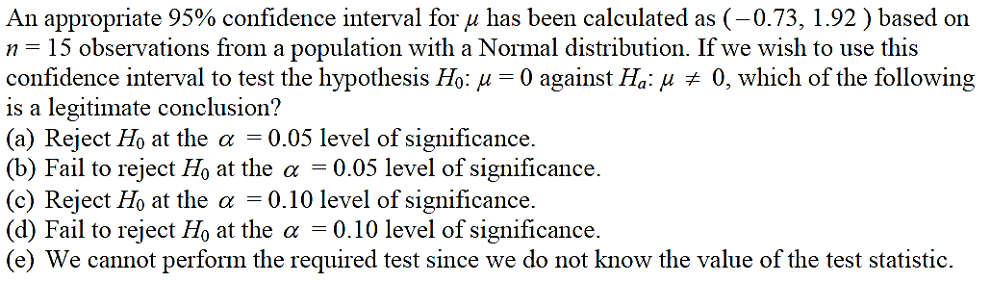12.

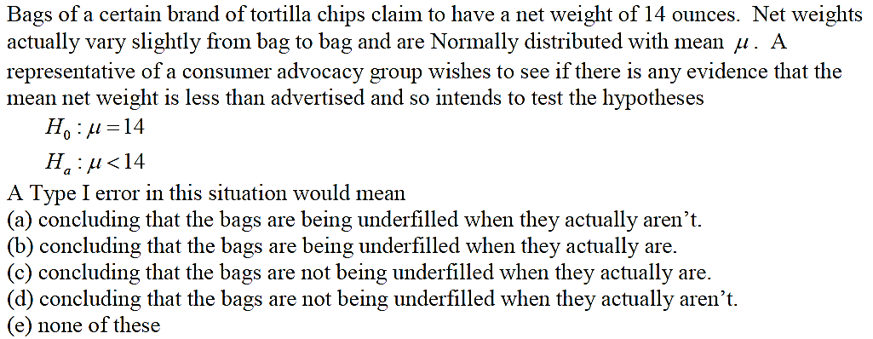13.

***FREE RESPONSE: COMMUNICATE CLEARLY AND COMPLETELY!***

14. It is believed that the average amount of money spent per U.S. household per week on food is about $98, with standard deviation $10. A random sample of 100 households in a certain affluent community yields a mean weekly food budget of $100. We want to test the hypothesis that the mean weekly food budget for all households in this community is higher than the national average.

(a) Perform a significance test at the  significance level.

(b) Describe a Type I error in the context of this problem. What is the probability of making a Type I error?

(c) Describe a Type II error in the context of this problem.

15. Does the use of fancy type fonts slow downthe reading of text on a computer screen? Adults can read four paragraphs of textin an average time of 22 seconds in the common Times New Roman font. Ask 25 adults to read this text in the ornate font named Gigi. Here are their times:

23.2 21.2 28.9 27.7 29.1 27.3 16.1 22.6 25.6

34.2 23.9 26.8 20.5 34.3 21.4 32.6 26.2 34.1

31.5 24.6 23.0 28.6 24.4 28.1 41.3

Is there good evidence that the mean reading time for Gigi is greater than 22 seconds? Carry out an appropriate test to help you answer this question.

16. You work for a large cruise ship company. The company is considering raising prices but also up-grading the food on the ships. You do a random survey of 500 past guests on various ships in the fleet. 281 of the respondents would pay more in exchange for better food. Using statistics and an appropriate test, do you recommend a change in pricing policy? (Having a proportion of more than .5 of the population in favor of the change)